**Linux Task: Simple Web Scanner Web App**

## **Task: Creating our own Web Scanner App**

1. Install Apache2, PHP and nmap

**↓**

1. Configure Ownership and Permissions (This is a Bad Idea) (*Refer to additional information)



**↓**

1. Cron Job Configuration



**↓**

**↓**

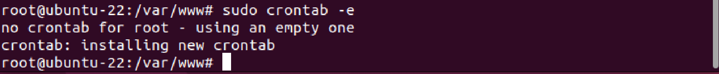

**↓**

1. Creating the network.php

**↓**

1. network.php

**↓**

## **\*Additional Information:** For CHMOD the tasks highlighted that it is a bad idea to provide 777 for permissions.

## Why? If it's bad, what is the alternative, please explain in words?

**Answer:**

**The `chmod 777` command in Linux gives all users (owner, group, and others) full permissions (read, write, execute) to a file or directory. However, this is generally not recommended due to potential security risks. It allows any user to modify or delete the file or directory, which could lead to unauthorized changes or data loss.**

**Instead, it's better to use more restrictive permissions. For example, `chmod 755` is often used for web server files. This gives the owner full permissions, but only allows read and execute permissions for the group and others. This means the owner can edit the files, but others can only view and run them.**

**Another common setting is `chmod 644`, which is used for files that should be readable by everyone, but only editable by the owner. It gives read and write permissions to the owner, and read-only permissions to the group and others.**

**In conclusion, it's important to carefully consider the necessary permissions for each file or directory, and to follow the principle of least privilege, which states that users should only be given the minimum permissions necessary to perform their tasks. This helps to maintain the security and integrity of your system.**